1.Please download VSCode from the link below:

<https://code.visualstudio.com/Download>

According to your computer operating system, to download the corresponding version, for example mine is Win7 64-bit operating system, so choose Windows 7, 8, 10 User Installer 64bit.

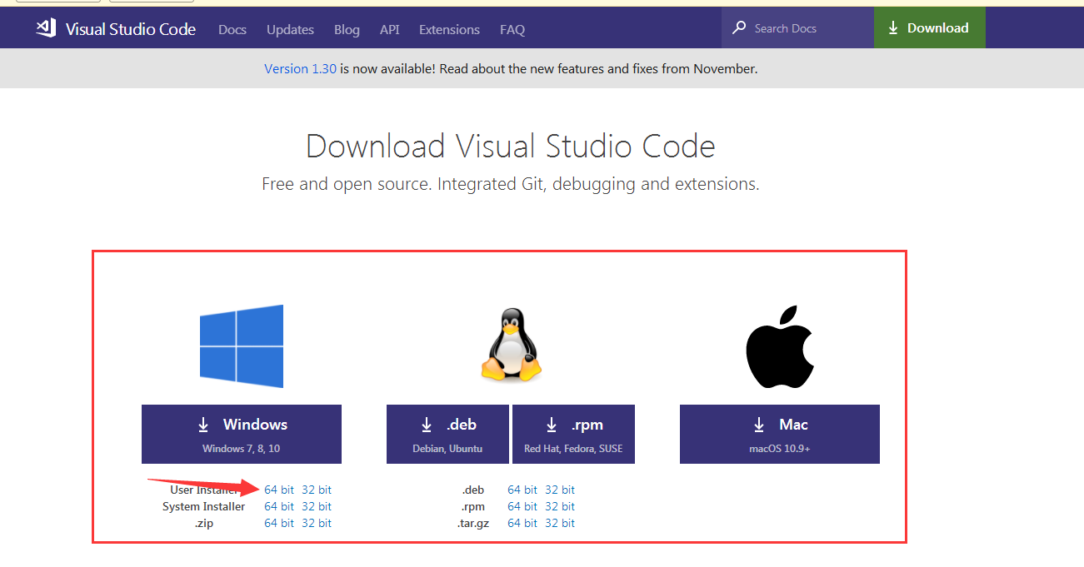

After the download is complete, double-click the installation. After the installation is complete, open VSCode.

2. You also need to install the PlatformIO plugin, please click on the ① in the picture below, enter PlatformIO in ② and click ③ Install to install.

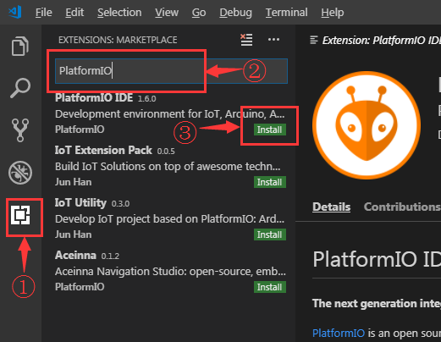

After the download is complete, you still need Reload

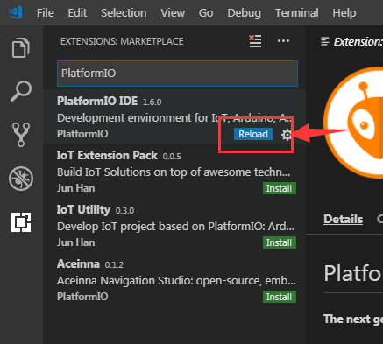

After Reload, you will be prompted to install PlatformIO Core, which takes a little time.

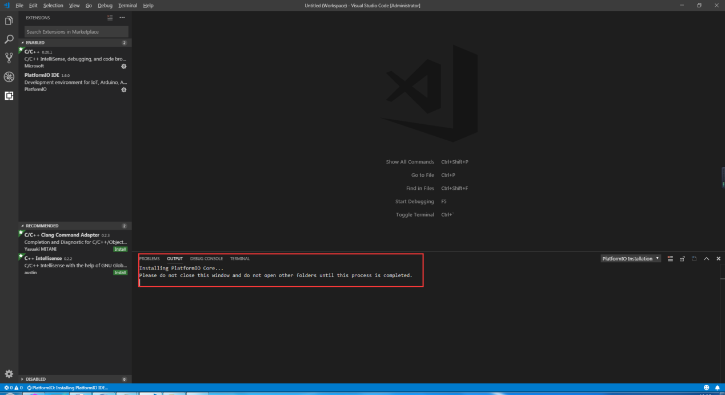

After the installation is successful, you need to reload again. After the Reload, the PlatformIO is installed.

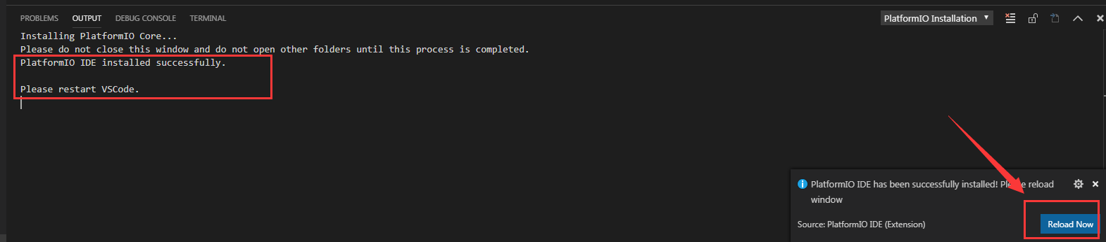

3.In the lower left corner of the VSCode, you can see that there’s one more icon, please see the picture(①), which is the PlatformIO plugin, and then click ② Open Project to open the project.

